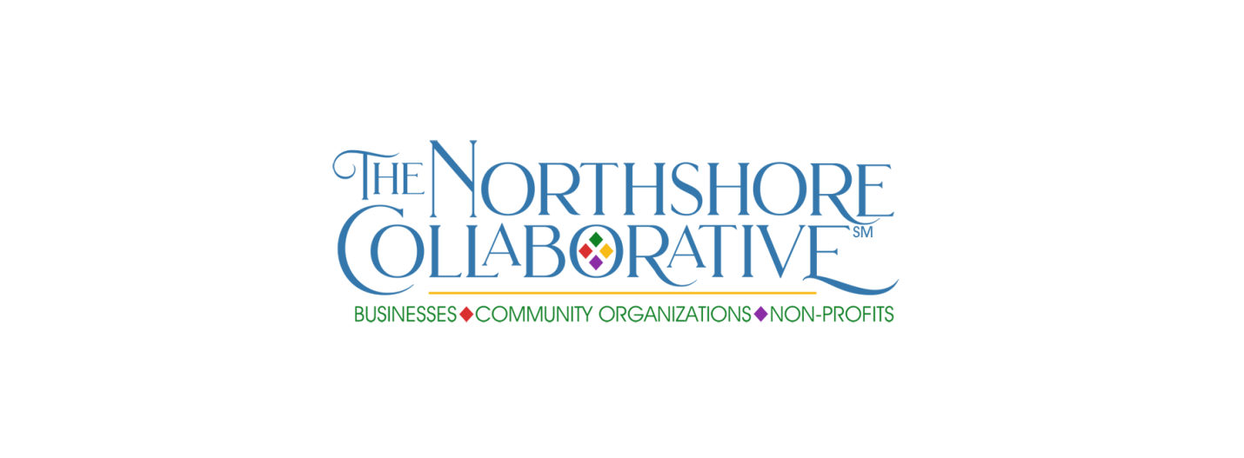
MEMBERS SOCIAL MEDIA FEATURE – COMMUNITY ORGANIZATION

Please provide all requested details for the social media campaign—fill in the blanks to make it efficient for us to cut and paste to the Northshore-Collaborative Facebook page. You must save to your hard drive before submitting, then send the saved document. Please do not send additional attachments—include all info in this form to expedite posting.

Please also send a photo (it can be your logo—preferred option-- or a group shot of staff) to Info@NSCollaborative.com.

Don’t forget to share your featured post plus those of your fellow Northshore Collaborative members when posted on our Facebook page (Facebook.com/Northshore-Collaborative)!

The social media campaign will rotate between our small business, community organizations non-profits and individual members, with the hashtags #IAmSmallBusiness, #WeAreCommunity and #WeAreNonProfit, #IAmCollaborative.

Community organization name ___________________________________________________________

Year established ___________ Number of members, if applicable (estimate acceptable) _____________

Contact name _________________________________________________________________________

Title _________________________________________________________________________________

Contact email _________________________________________________________________________

Organization/business address ___________________________________________________________

City _______________________________________________ State _____________ Zip _____________

Organization email _____________________________________________________________________

Phone for public contact ________________________________________________________________

Include in post? Contact info: Name ☐ Yes ☐ No Title ☐ Yes ☐ No Email ☐ Yes ☐ No
Organization/business address ☐ Yes ☐ No Organization phone ☐ Yes ☐ No

Website (if applicable) __________________________________________________________________

Facebook (if applicable) _________________________________________________________________

(see page 2)

What you do (a few sentences)

Signature project(s) - optional

Mission Statement – optional

Anything else you wish to add, including why you have joined Northshore Collaborative, what you hope to gain from membership, how the organization members can serve you (volunteer recruitment, participate in events, other)

Please save the completed form to your computer hard drive, then email the saved document to
Info@NSCollaborative.com. Please do not include additional documents or attachments.

Thank you for being part of The Northshore Collaborative!

