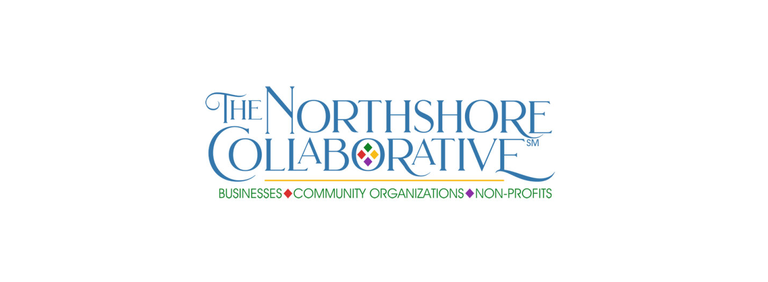
MEMBERS SOCIAL MEDIA FEATURE – INDIVIDUAL MEMBER

Please provide all requested details for the social media campaign—fill in the blanks to make it efficient for us to cut and paste to the Northshore-Collaborative Facebook page. You must save to your hard drive before submitting, then send the saved document. Please do not send additional attachments—include all info in this form to expedite posting.

Please also send a photo (if you would like that to be included with your #IAmCollaborative post) to Info@NSCollaborative.com.

Don’t forget to share your featured post plus those of your fellow Northshore Collaborative members when posted on our Facebook page (Facebook.com/Northshore-Collaborative)!

The social media campaign will rotate between our small business, community organizations non-profits and individual members, with the hashtags #IAmSmallBusiness, #WeAreCommunity and #WeAreNonProfit, #IAmCollaborative.

Member name ________________________________________________________________________

Business/Organization (if applicable) _______________________________________________________

Title (if applicable) _____________________________________________________________________

Contact email _________________________________________________________________________

Address ______________________________________________________________________________

City _______________________________________________ State _____________ Zip _____________

Phone _______________________________________________________________________________

Include in post? Name ☐ Yes ☐ No Organization ☐ Yes ☐ No Title ☐ Yes ☐ No
Email ☐ Yes ☐ No Address ☐ Yes ☐ No Phone ☐ Yes ☐ No

Website (if applicable) __________________________________________________________________

Facebook (if applicable) _________________________________________________________________

Reasons for joining The Northshore Collaborative:

Anything else you wish to add, including what you hope to gain from membership, how you wish to participate, skills or services you wish to offer other members:

What you love about our community (optional):

Please save the completed form to your computer hard drive, then email the saved document to
Info@NSCollaborative.com. Please do not include additional documents or attachments.

Thank you for being part of The Northshore Collaborative!

