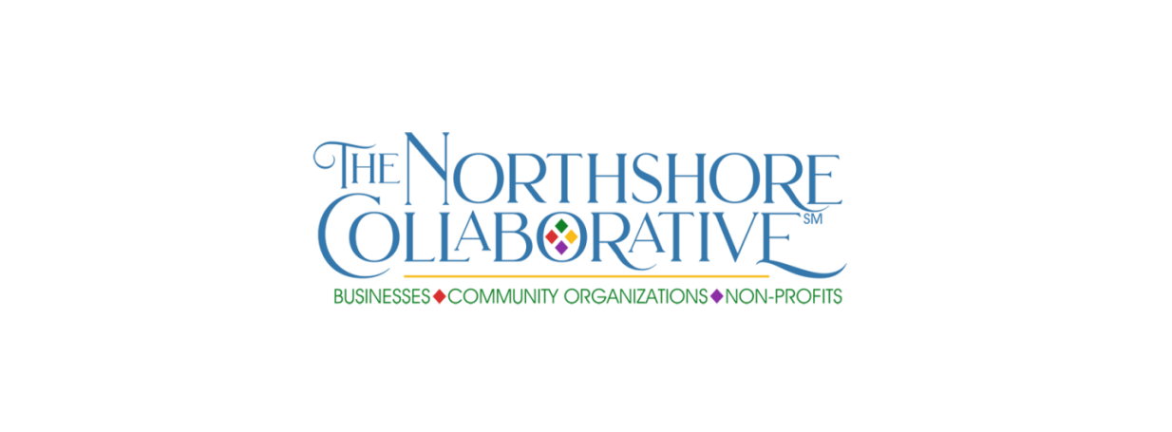

MEMBERS SOCIAL MEDIA FEATURE – NON-PROFIT ORGANIZATION

Please provide all requested details for the social media campaign—Fill in the blanks to make it easy for us to cut and paste to the Northshore-Collaborative Facebook page. You must save to your hard drive before submitting, then send the saved document. Please do not send additional attachments—include all info in this form to expedite posting.

Please also send a photo (it can be your logo—preferred option—or a group shot of staff) to Info@NSCollaborative.com.

Don’t forget to share your featured post plus those of your fellow Northshore Collaborative members when posted on our Facebook page (Facebook.com/Northshore-Collaborative)!

The social media campaign will rotate between our small business, community organizations non-profits and individual members, with the hashtags #IAmSmallBusiness, #WeAreCommunity and #WeAreNonProfit, #IAmCollaborative.

Contact name, title and email
(this will not be included in post) __________________________________________________________

Non-profit name _______________________________________________________________________

Executive Director (if applicable) __________________________________________________________

Year founded _________________________________________________________________________

Mission Statement

Address ______________________________________________________________________________

Phone for contact from public _________________________ ___________________________________

Facebook page (optional) ________________________________________________________________

Website, if any (optional) _______________________________________________________________

What you do (a few sentences)

Signature project(s), if applicable __________________________________________________________

_____________________________________________________________________________________

Anything else you wish to add, including why you have joined The Northshore Collaborative, what you hope to gain from membership, how the organization can serve you (volunteer recruitment, participate in events, other.)

Please save the completed form to your computer hard drive, then email the saved document to
Info@NSCollaborative.com. Please do not include additional documents or attachments.

Thank you for being part of The Northshore Collaborative!

