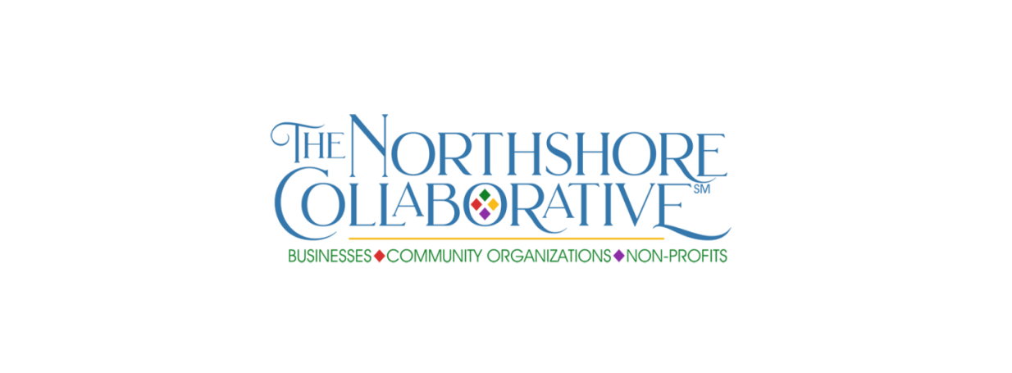

MEMBERS SOCIAL MEDIA FEATURE – SMALL BUSINESS #IAmSmallBusiness

Please provide all requested details for the social media campaign—Fill in the blanks to make it easy for us to cut and paste to the Northshore-Collaborative Facebook page. You must save to your hard drive before submitting, then send the saved document. Please do not send additional attachments—include all info in this form to expedite posting.

Please also send a photo (it can be your logo—preferred option-- or a group shot of staff) to Info@NSCollaborative.com.

Don’t forget to share your featured post plus those of your fellow Northshore Collaborative members when posted on our Facebook page (Facebook.com/Northshore-Collaborative)!

The social media campaign will rotate between our small business, community organizations non-profits and individual members, with the hashtags #IAmSmallBusiness, #WeAreCommunity and #WeAreNonProfit, #IAmCollaborative.

Contact name _________________________________________________________________________

Title _________________________________________________________________________________

Contact email _________________________________________________________________________

Include in post? Contact name ☐ Yes ☐ No Title ☐ Yes ☐ No Email ☐ Yes ☐ No

Business name ________________________________________________________________________

Year established _______________________________________________________________________

Business address _______________________________________________________________________

City _______________________________________________ State _____________ Zip _____________

Business phone ________________________________________________________________________

Website (if applicable) __________________________________________________________________

Facebook (if applicable) _________________________________________________________________

What you do (a few sentences, i.e. We offer personal and business products/services for etc etc):

Thoughts about what it means to be a small business OR challenges you have learn to overcome as a small business OR understanding the power of business networking as a critical component of doing business:

Please save the completed form to your computer hard drive, then email the saved document to
Info@NSCollaborative.com.

Thank you for being part of The Northshore Collaborative!

